Read Me

# Help

For help, go to the [ABS website](http://www.abs.gov.au/). Navigate to the Census home page and then the [DataPacks page](http://www.abs.gov.au/websitedbs/censushome.nsf/home/datapacks?opendocument&navpos=250). On the right hand side of the page you will find links to: Help, FAQs and tutorials.

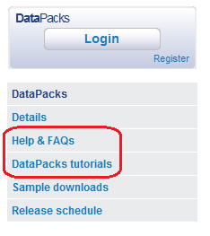

## National Information and Referral Service (NIRS)

NIRS consultants have been trained in the range of statistical data and information that is produced by the Australian Bureau of Statistics (ABS). For straightforward enquiries, we are able to provide limited free data and information to you over the phone. For complex or wide-ranging enquiries about ABS data, we can assist you to find what you need, using resources available through this web site and/or many public libraries. In some instances, data may need to be compiled for you on a fee-for-service basis.

National Information and Referral Service (NIRS) Ph: 1300 135 070.

# MapInfo users

To open the 2011 DataPacks boundary files you need to use MapInfo version 7.8 or above.

When creating .tab files in MapInfo for SA1, SA2, SA3, SA4, STE or SLA, the 'region ID' in the CSV file has to be changed from 'integer' or 'small integer' to 'character', before merging with the corresponding boundary file.

For details see MapInfo – converting region ID from numeric to character field

# ArcGIS users

When working with data files for SA1, SA2, SA3, SA4, STE or SLA, the 'region ID' in the CSV file has to be changed from numeric to text field, before merging with the corresponding boundary file.

For details see ArcGIS – converting region ID from numeric to text field

# Summary of DataPacks

## What you get in a DataPack

DataPacks contain data for Census geographical areas ranging from Statistical Area Level 1 to the whole of Australia. They include geography boundary files, metadata and reference documents to enable you to read the data.

Metadata files contain the information you need to match the data with the Community Profile template, such as information about the sequential numbers and labels, the digital boundaries, the table descriptors, and the population that is being counted. The Metadata folder also contains the geographical description file: 2011Census_geog_desc.xlsx.

DataPacks do not include software.

## Using the DataPacks

You can use DataPacks if you:

* want to use the data with your own database or analysis systems
* want Community Profile data for numerous geographic areas.

Once you have Census data in your Geographic Information System (GIS), you can merge the data with the digital boundaries.

The data items in DataPacks are contained in CSV files.

### Descriptors

There are three options for column labels in the 2011 DataPacks. You can use the sequential number labels, short descriptors (up to 29 characters) or long descriptors. Short descriptors were created for use with Geographic Information System (GIS) software.

The example below, using Local Government Area (LGA) geography, shows the three options for descriptors.

Columns with sequential number labels

|  |  |  |  |
| --- | --- | --- | --- |
| region_id | B1 | B2 | B3 |
| LGA10050 | 0 | 0 | 0 |
| LGA10110 | 0 | 0 | 0 |
| LGA10150 | 0 | 0 | 0 |

Columns with short descriptor labels

|  |  |  |  |
| --- | --- | --- | --- |
| region_id | Tot_P_M | Total_P_F | Total_P_P |
| LGA10050 | 0 | 0 | 0 |
| LGA10110 | 0 | 0 | 0 |
| LGA10150 | 0 | 0 | 0 |

Columns with long descriptor labels

|  |  |  |  |
| --- | --- | --- | --- |
| region_id | Total_Persons_Males | Total_Persons_Females | Total_Persons_Persons |
| LGA10050 | 0 | 0 | 0 |
| LGA10110 | 0 | 0 | 0 |
| LGA10150 | 0 | 0 | 0 |

## Sample DataPacks

Sample DataPacks contain the data structure (geography boundaries and Census item descriptors) but no Census data. They are available for download from the ABS website now.

Sample DataPacks are only available for the following profiles:

* Basic Community Profile
* Aboriginal and Torres Strait Islander Peoples (Indigenous) Profile
* Time Series Profile.

## DataPacks on DVD

The initial release of DataPacks will be on DVD, mailed from the ABS.

DataPacks will also be available to download from our website for free. Downloads become available a couple of weeks later than the DVDs.

DataPacks on DVD will be available for the Community Profiles and will include all Census geographical areas ranging from Statistical Area Level 1 to the whole of Australia.

## Price

DVDs are priced to recover administrative and production costs. The data is free.

The Community Profile DataPacks are not sold on separate DVDs but are sold as compilations.

One DVD has the DataPacks for:

* Basic Community Profile
* Aboriginal and Torres Strait Islander Peoples (Indigenous) Profile
* Time Series Profile DataPacks.

Another DVD has the DataPacks for:

* Place of Enumeration Profile
* Expanded Profile
* Working Population Profile (this is on the second release DVD only).

Each of these DVDs costs $100 (including postage and GST). This price includes the second and third release DVDs which will also be mailed to you.

The Estimated Resident Population costs $50 (including postage and GST).

All DataPacks on DVD costs $250.

## Ordering

You can order DataPack DVDs now, by phoning our National Information and Referral Service on 1300 135 070. International callers phone +61 2 9268 4909. You do not need to be a registered user.

You will need to give the catalogue number for the type of DataPack you want to buy:

* Basic Community, Aboriginal and Torres Strait Islander Peoples and Time Series Profiles, DVD cat. no. 2069.0.30.008
* Place of Enumeration, Expanded and Working Population Profiles, DVD cat. no. 2069.0.30.009
* Estimated Resident Population, DVD cat. no. 2069.0.30.010.

The DataPack will then be mailed to you on the day of data release.

### Release dates for DataPacks on DVD

|  |  |  |  |
| --- | --- | --- | --- |
| **DataPack** | **First Release** | **Second Release** | **Third Release** |
| BCP | 21 Jun 2012 | 30 Oct 2012 | 28 Mar 2013 |
| IP | 21 Jun 2012 | 30 Oct 2012 | 28 Mar 2013 |
| TSP | 21 Jun 2012 | 30 Oct 2012 | .. |
| PEP | 21 Aug 2012 | 20 Nov 2012 | 28 Mar 2013 |
| XCP | 21 Aug 2012 | 20 Nov 2012 | .. |
| WPP | .. | 20 Nov 2012 | .. |
| ERP | .. | .. | 26 Aug 2013 |

.. not applicable

The table above shows the availability of data on DVD for the first, second and third releases. The release dates are the dates on which the DataPacks will be mailed from the ABS.

The third release for the Basic Community Profile, Indigenous Profile and Place of Enumeration Profile will include Remoteness Area, but no new tables.

## DataPacks online

DataPacks are available to download free of charge from our website. You will need to register to download DataPacks. You are advised to register early, as high levels of traffic on the website are expected on release dates.

When you download a DataPack, you will choose the profiles and descriptor types as well as the type of geographic area.

### Release dates for DataPacks online

|  |  |  |  |
| --- | --- | --- | --- |
| **DataPack** | **First Release** | **Second Release** | **Third Release** |
| BCP | 10 Jul 2012 | 20 Nov 2012 | 28 Mar 2013 |
| IP | 10 Jul 2012 | 20 Nov 2012 | 28 Mar 2013 |
| TSP | 10 Jul 2012 | 20 Nov 2012 | .. |
| PEP | 3 Sep 2012 | 20 Nov 2012 | 28 Mar 2013 |
| XCP | 3 Sep 2012 | 20 Nov 2012 | .. |
| WPP | .. | 20 Nov 2012 | .. |
| ERP | .. | .. | 26 Aug 2013 |

.. not applicable

The table above shows the data available to download from the Census website for the first, second and third releases.

The third release for the Basic Community Profile, Indigenous Profile and Place of Enumeration Profile will include Remoteness Area, but no new tables.

Availability of geographic structures  
The following tables show the availability of data for each geographic area, for the first, second and third releases.

Legend:

1 = DataPack first release data

2 = DataPack second release data

3 = DataPack available after second release

Abbreviations for geographic structures are listed after the tables.

### Geography: ABS structures

|  |  |  |  |  |  |  |  |  |  |  |  |  |  |  |  |
| --- | --- | --- | --- | --- | --- | --- | --- | --- | --- | --- | --- | --- | --- | --- | --- |
| DataPack | Aust | STE | SA4 | SA3 | SA2 | SA1 | GCCSA | IREG | IARE | ILOC | SUA | UC/L | SOS | SOSR | RA |
| BCP | 1 | 1 | 1 | 1 | 1 | 1 | 1 |  |  |  | 2 | 2 | 2 | 2 | 3 |
| PEP | 1 | 1 | 1 | 1 | 1 | 1 | 1 |  |  |  | 2 | 2 | 2 | 2 | 3 |
| IP | 1 | 1 | 1 | 1 | 1 |  | 1 | 1 | 1 | 1 |  |  |  |  | 3 |
| TSP | 1 | 1 | 1 | 1 | 1 |  | 1 |  |  |  |  |  |  |  |  |
| XCP | 1 | 1 | 1 | 1 | 1 |  | 1 |  |  |  | 2 |  |  |  |  |
| WPP | 2 | 2 | 2 | 2 | 2 |  | 2 |  |  |  |  |  |  |  |  |
| ERP | 3 | 3 | 3 | 3 | 3 |  | 3 |  |  |  |  |  |  |  |  |

### Geography: Non-ABS structures

|  |  |  |  |  |  |  |
| --- | --- | --- | --- | --- | --- | --- |
| DataPack | LGA | SLA | SSC | POA | CED | SED |
| BCP | 1 | 1 | 1 | 1 | 1 | 1 |
| PEP | 1 | 1 | 1 | 1 | 1 | 1 |
| IP | 1 | 1 |  |  |  |  |
| TSP | 1 | 1 |  |  |  |  |
| XCP | 1 | 1 |  |  |  |  |
| WPP | 2 | 2 |  |  |  |  |
| ERP | 3 | 3 |  |  |  |  |

### Abbreviations

|  |  |
| --- | --- |
| Aust | Australia |
| CED | Commonwealth Electoral Divisions |
| GCCSA | Greater Capital City Statistical Areas |
| IARE | Indigenous Areas |
| ILOC | Indigenous Locations |
| IREG | Indigenous Regions |
| LGA | Local Government Areas |
| POA | Postal Areas |
| RA | Remoteness Areas |
| SA1 | Statistical Area Level 1 |
| SA2 | Statistical Area Level 2 |
| SA3 | Statistical Area Level 3 |
| SA4 | Statistical Area Level 4 |
| SED | State Electoral Divisions |
| SLA | Statistical Local Areas |
| SOS | Section of State |
| SOSR | Section of State Ranges |
| SSC | State Suburbs |
| STE | States and Territories |
| SUA | Significant Urban Areas |
| UC/L | Urban Centres and Localities |

# Summary of Community Profiles

The community profiles are released in two phases. First release tables are those containing variables which are relatively easy to process and will be available on release day. Second release tables contain variables which require more complex processing and will be available on the second release day.

## Basis for counting people

* 'Place of usual residence' data counts people where they usually live.
* 'Place of enumeration' is the place at which the person is counted i.e. where he/she spent Census Night, which may not be where he/she usually lives.
* 'Place of work' data provides information on where a person goes to work.

## Templates

The templates provide an easy way for you to visualise all data cells available in the data files. They contain the formatted tables and the corresponding cell reference numbers. The templates are in the Metadata folder.

|  |  |
| --- | --- |
| **Community profile** | **Template** |
| BCP | 2011_BCP_datapack_sequential_template.xls |
| IP | 2011_IP_datapack_sequential_template.xls |
| TSP | 2011_TSP_datapack_sequential_template.xls |
| PEP | 2011_PEP_datapack_sequential_template.xls |
| XCP | 2011_XCP_datapack_sequential_template.xls |
| WPP | 2011_WPP_datapack_sequential_template.xls |

## Community profiles in brief

### Basic Community Profile (BCP)

* The BCP contains the Census characteristics on persons, families and dwellings.
* The data is based on place of usual residence.
* Tables B01-B36 were released on 21 June 2012. Tables B37-B46 are released on 30 October 2012.
* Boundaries for Remoteness Areas are released on 28 March 2013.

### Aboriginal and Torres Strait Islander Peoples (Indigenous) Profile (IP)

* The IP contains the Census characteristics of Indigenous persons and households. Some tables provide comparisons with the non-Indigenous population.
* The data is based on place of usual residence.
* Tables I01-I13 were released on 21 June 2012. Tables I14-I16 are released on 30 October 2012.
* Boundaries for Remoteness Areas are released on 28 March 2013.

### Time Series Profile (TSP)

* The TSP contains the Census characteristics of persons, families and dwellings.
* The data is based on place of enumeration.
* Tables T01-T27 were released on 21 June 2012. Tables T28-T34 are released on 30 October 2012.
* The TSP has data from the 2001, 2006 and 2011 censuses. Where classifications have been revised, data are output on the classification used for the 2011 Census.

### Place of Enumeration (PEP)

* The PEP contains the Census characteristics of persons, families and dwellings.
* The data is based on place of enumeration.
* Tables P01-P36 were released on 21 August 2012. Tables P37-P44 are released on 20 November 2012.
* Boundaries for Remoteness Areas are released on 28 March 2013.

### Expanded Community Profile (XCP)

* The XCP is the most comprehensive Profile providing extended data on the Census characteristics of persons, families and dwellings.
* The data is based on place of usual residence.
* Tables X01-X32 were released on 21 August 2012. Tables X33-X42 are released on 20 November 2012.
* Tables within this profile contain more detailed versions of the Basic Community Profile tables, plus additional tables relating to relationships within a family, living costs and dwelling structures.

### Working Population Profile (WPP)

* The WPP contains the Census characteristics of employed persons.
* This data is based on the Journey to Work areas.
* All 23 WPP tables are released on 27 November 2012.

# Installing the DataPack on your hard drive

The Census profile DVDs include three DataPacks. For example the BCP, IP and the TSP. We suggest that you copy the selected DataPack (or DataPacks) you are going to use, to your computer's hard drive.

You should then create a new folder in the directory of your choice before unzipping the data. If you were copying the BCP for example, you might name the folder 'Census 2011 BCP release 1'.

When you unzip the files, you can unzip them to this directory and this will keep the CSV data files together with the digital boundary files for ASGS.

The second release DVD contains the entire contents of the first release DVD, plus the second release tables.

The third release DVD contains the entire contents of the first and second release DVDs, plus remoteness area boundaries. Remoteness areas are only applicable to the BCP, IP and TSP.

# File format

## CSV files format

CSV files are in the format:

Table number_state_geography.csv

'Table number' is the Community Profile table number.

For instance:

* Basic Community Profile tables are numbered B1, B2 etc.
* Time Series Profile tables are numbered T1, T2 etc.

For each CSV file there is a limit of 200 data items. For tables with more than 200 data items, additional CSV files are created.

In the Basic Community Profile for example, table B4 has 297 data items. The CSV file which contains the first 200 data items is named B04A... and the file with the remaining 97 data items is named B04B...

# Directory structures for (1) DataPacks on DVD, (2) DataPacks Online

## (1) DataPacks on DVD

The hierarchy for the file directory is:

CENSUS YEAR, DATAPACK TYPE, RELEASE NUMBER

2011 Aboriginal and Torres Strait Islander Peoples Profile Release 1

2011 Basic Community Profile Release 1

2011 Time Series Profile Release 1

DESCRIPTOR TYPE

Long Descriptor

Sequential Number Descriptor

Short Descriptor

GEOGRAPHY TYPE

(Geography types vary based on the Community Profile.

These geography types are for the Basic Community Profile.)

AUST

CED

GCCSA

LGA

POA

SA1

SA2

SA3

SA4

SED

SLA

SSC

STE

STATE/AUSTRALIA

ACT

AUST

NSW

NT

OT

QLD

SA

TAS

VIC

WA

CSV files are in the format:

2011Census_<Table reference>_<State>_<Geography>_<Descriptor type>.csv

## For example (DataPacks on DVD)

To access the first five tables (csv files) of the Basic Community Profile showing short descriptors for the geography of Statistical Area Level 4 for Western Australia.

Select: 2011 Basic Community Profile Release 1/ Short Descriptor/ Statistical Area Level 4/ WA.

**2011 Basic Community Profile Release 1**

**Short Descriptor**

AUST

CED

GCCSA

LGA

POA

SA1

SA2

SA3

**SA4**

ACT

AUST

NSW

NT

OT

QLD

SA

TAS

VIC

**WA**

2011Census_B01_WA_SA4_short.csv

2011Census_B02_WA_SA4_short.csv

2011Census_B03_WA_SA4_short.csv

2011Census_B04A_WA_SA4_short.csv

2011Census_B04B_WA_SA4_short.csv

2011Census_B05_WA_SA4_short.csv

## (2) DataPacks Online

The directory structure will depend on which files you choose to download.

The hierarchy for the file directory is:

CENSUS YEAR, DATAPACK TYPE, GEOGRAPHY TYPE FOR STATE/AUSTRALIA

(Geographies may be all for Australia or a State/Territory – example below)

2011 Census BCP All Geographies for AUST

2011 Census BCP All Geographies for NSW (VIC, QLD, SA, WA, Tas, NT, ACT, OT)

2011 Census BCP Statistical Areas Level 4 for Australia (or other applicable Geography types)

2011 Census BCP Statistical Areas Level 4 for NSW (VIC, QLD, SA, WA, Tas, NT, ACT, OT)

GEOGRAPHY TYPE

(Geography types vary based on the Community Profile.

These geography types are for the Basic Community Profile.)

AUST

CED

GCCSA

LGA

POA

SA1

SA2

SA3

SA4

SED

SLA

SSC

STE

STATE/AUSTRALIA

ACT

AUST

NSW

NT

OT

QLD

SA

TAS

VIC

WA

CSV files are in the format:

2011Census_<Table reference>_<State>_<Geography>_<Descriptor type>.csv

## For example (DataPacks Online)

Presuming you have downloaded Basic Community Profile with short descriptors.

To access the first five tables (csv files) of the Basic Community Profile showing short descriptors for the geography of Statistical Area Level 4 for Western Australia.

Select: 2011 Census BCP Statistical Areas Level 4 for WA/WA.

2011 Census BCP Statistical Areas Level 4 for WA

**WA**

2011Census_B01_WA_SA4_short.csv

2011Census_B02_WA_SA4_short.csv

2011Census_B03_WA_SA4_short.csv

2011Census_B04A_WA_SA4_short.csv

2011Census_B04B_WA_SA4_short.csv

2011Census_B05_WA_SA4_short.csv

# MapInfo – converting region ID from numeric to character field

#### This is applicable to MapInfo only.

When creating '.tab' files in MapInfo for SA1, SA2, SA3, SA4, STE or SLA, the 'region ID' in the CSV file has to be changed from field type of 'integer' or 'small integer' to 'character', before merging with the corresponding boundary file.

This is not necessary with other geographies. The '.tab' files for other geographies can be opened and merged with the data file in the usual way.

## To do this:

Open MapInfo.

(In this example we are using MapInfo Professional 10.5)

Cancel 'Quick Start'.

Select 'File'.

(In this example we are using SA4 geography for South Australia)

Select 'Open'.

When the 'Open' tile appears:

* In the field 'Files of type' select 'Comma delimited CSV'.
* Select your CSV file.
* Tick the 'Create copy in MapInfo format for read/write' box.
* Press the 'Open' button.

The 'Comma Delimited CSV Information' tile appears.

Tick the 'Use First Line for Column Titles' box.

Then press the 'OK' button.

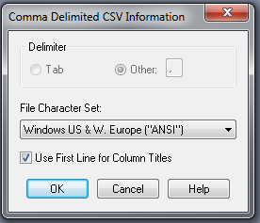

The file will open.

Select, 'Table'/'Maintenance'/'Table Structure'.

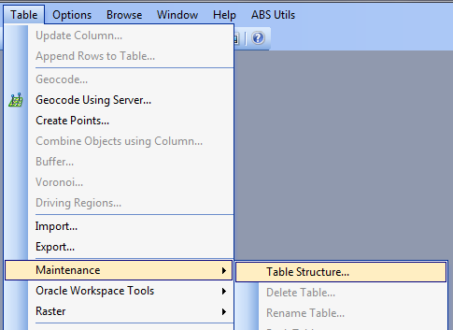

Change 'Small Integer' or 'Integer' to 'Character'.

The change to 'Character' will bring up the 'Width' box.

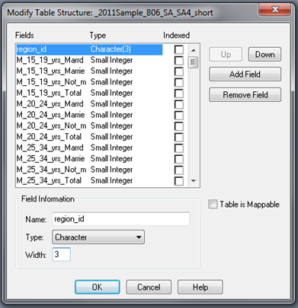

The 'width' is the number of characters in the geography code.

In this case the geography is SA4. SA4s have three digit codes.

You can see this under 'region ID' below.

Then press OK.

Note: Some geographies will have codes of more than three numerals and so will have commas.

When counting the number of characters for the 'width' field, exclude the commas from the count.

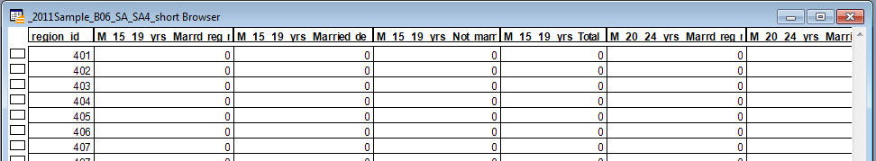

A tile will appear saying:

‘One or more fields have been shortened or removed. The resulting loss of data cannot be undone.’

Press OK button and you have finished.

The data file can now be merged with the corresponding boundary file.

# ArcGIS – converting region ID from numeric to text field

#### This is applicable to ArcGIS only.

When working with data files for SA1, SA2, SA3, SA4, STE or SLA, the 'region ID' in the CSV file has to be changed from numeric to text field, before merging with the corresponding boundary file.

This is not necessary with other geographies. The '.tab' files for other geographies can be opened and merged with the data file in the usual way.

## To do this:

Open ArcGIS > ArcMap.

(In this example we are using ArcMap 10)

Cancel ‘ArcMap Getting started'.

Select 'Windows > Catalog’

In the Catalog window, right click on 'Folder Connections > Connect Folder’

Navigate to the folder location of the data file(s) to connect to folder for access in ArcMap.

Select the data file(s) you would like to convert the region ID field from numeric to character.

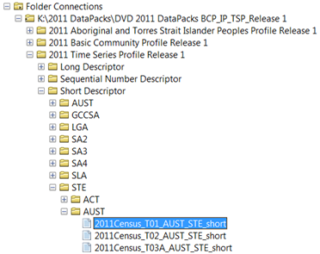

Drag and drop the data file into your workspace (middle panel where maps are displayed).

Your data file should appear within the Layers in your Table of contents window.

Right click on csv file in the Table of contents window, select ‘Data > Export’.

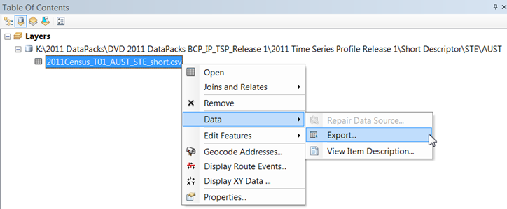

Click on the ‘browse’ folder icon.

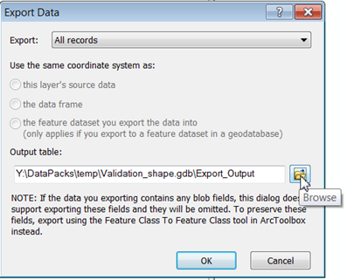

Navigate to your ‘Folder Connections’ and select a folder to create a new Geodatabase, to store exported csv files (if you do not have one already).

To do this, select the highlighted icon to create a database.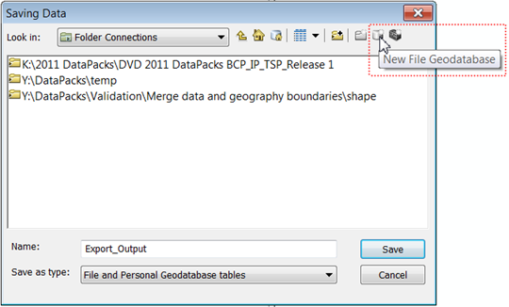

Give a new name to your database (in this example as ‘***Validation_shape.gdb***’).

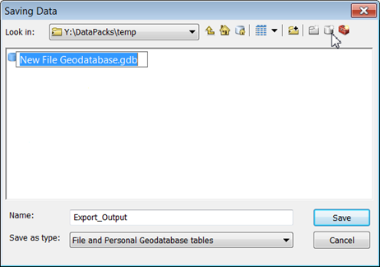

Double click on your new geodatabase created.

Name your exported file (here named as ‘***T01_AUST_STE***’ – note name has a 13 character limit).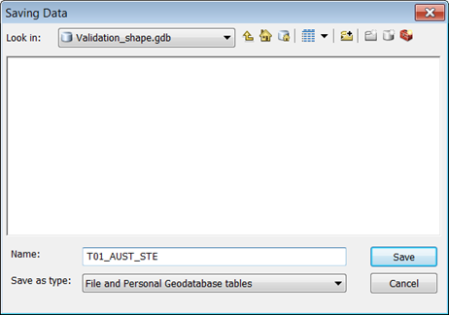

Select ‘Save’.

The following dialog box should appear – select ‘OK’ note output destination database and file name.

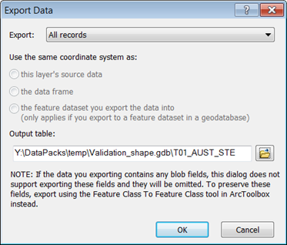

After the file is exported, a dialog box will appear with ‘Do you want to add the new table to the current map’ – select ‘Yes’.

In Table of contents panel – open your new file within the database you created

(example here is ‘T01_AUST_STE’).

Right click on file and select ‘Open’.

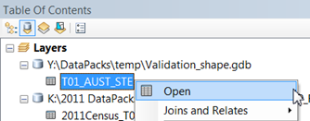

In the table that opens, select the drop down menu and ‘Add Field’.

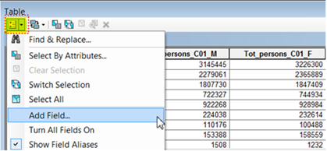

Assign name to new field e.g. ‘***region_id_txt***’ and select type as ‘Text’, then select OK.

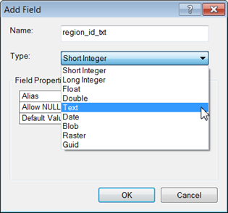

In the table, scroll to the last column to locate new field.

Right click on ‘region_id_txt’ then select ‘field calculator’.

Double click on ‘region_id’ so that your new text field is equal to the contents of ‘region_id’

Select ‘OK’

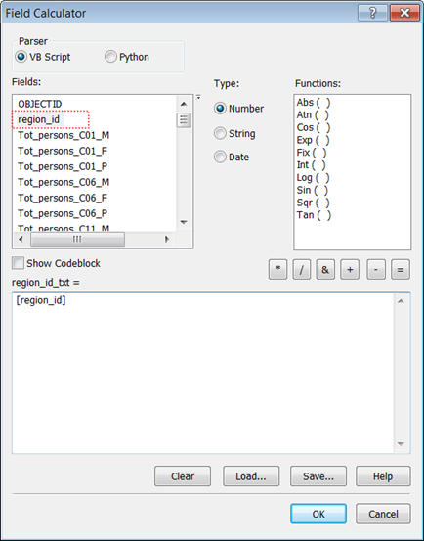

You can now merge the boundary file (state_code from STE boundary in this example) with the data file (T01_AUST_STE in this example) using the new text field ‘region_id_txt’.

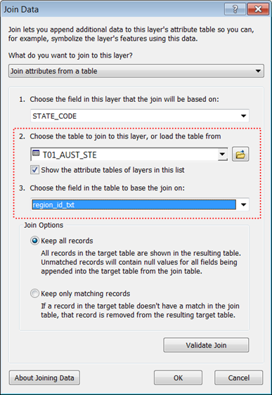

# Adding geographic labels to DataPack files

The following guide will walk you through the process of attaching geographic labels to DataPack .csv files using Microsoft Excel.

Step 1: Obtain relevant files

As an example, Basic Community Profile DataPacks, separated into Local Government Areas (LGA’s) for NSW with short descriptors should look something like this in your directory:

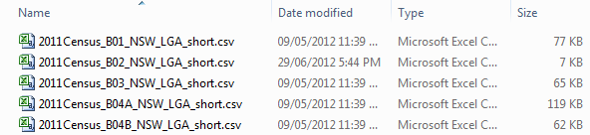

You’re also going to need the geographical description file (2011Census_geog_desc.xlsx) in order to extract the relevant labels/names and attach them to the DataPack files. The geographical description file is located in the ‘Metadata’ folder.

Step 2: Making room for geographic labels in the DataPack file

In this example, we’ll be opening ‘2011Census_B01_NSW_LGA_short.csv’ in Microsoft Excel and inserting two blank columns.

Simply highlight the entire column A and column B as so:

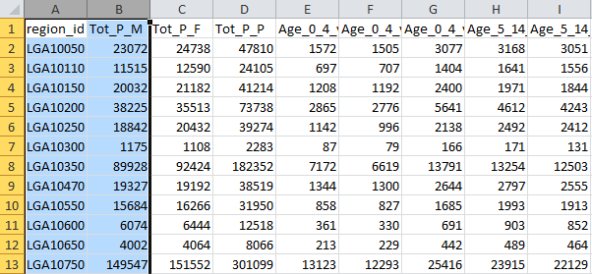

And then select ‘Insert Cells’ from the MS Excel Ribbon Menu:

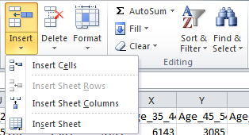

Alternatively, you can use the keyboard shortcut <ctrl>+<+>.

Your DataPack file should now appear as follows:

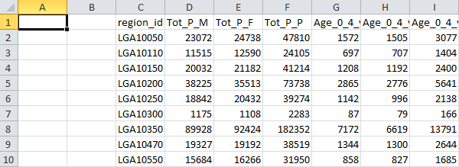

Step 3: Extracting geographic labels

Open the file named ‘2011Census_geog_desc.xlsx’ and search for the relevant region ID’s relevant to the DataPack file that you’re working with. In this case, we want to locate NSW LGA codes (you can utilise the MS Excel Find function by pressing <ctrl>+<f>):

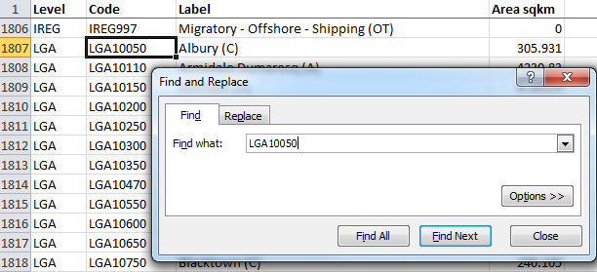

Highlight the Code and Label columns for LGA codes LGA10050 through to LGA19499 and press <ctrl>+<c> to copy the data to Microsoft’s clipboard:

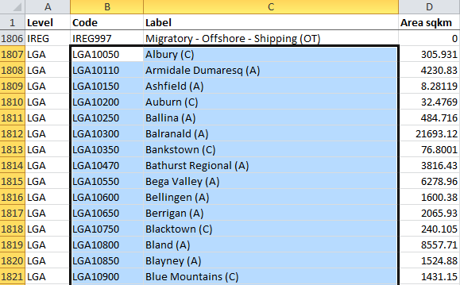

Step 4: Pasting the geographic labels into the DataPack files

Now simply return to the DataPack file that we manipulated in Step 2, click on cell A2 and press <ctrl>+<v> to paste the labels that we extracted/copied in Step 3.

For headings, you can type ‘Code’ and ‘Label’ into the top of Column A and Column B:

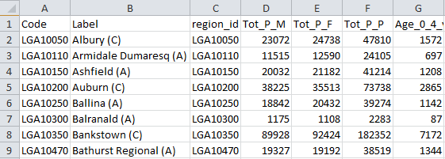

Step 5: Saving

Now that you’ve finished altering the DataPack file to include geographic labels, simply save the .csv file in a location of your choice and repeat the process for as many DataPack files that you’d like to alter.

Appendix 1: Checking that the ‘Code’ and ‘region id’ columns match

The ‘Code’ and ‘region_id’ columns should match exactly, though to be sure that they do you can utilise the following MS Excel check:

* Insert a blank Column A the same way we did in Step 2 and include the heading ‘Check’:

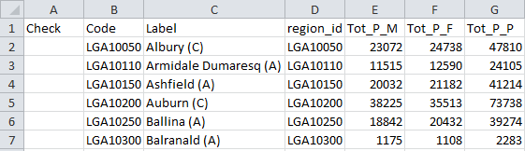

* Now highlight the column (A2:A155 in this example), type the formula =EXACT(B2,D2) and press <ctrl>+<Enter> to copy the formula down for all of the cells.

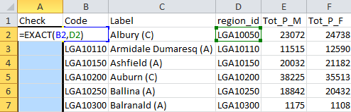

* If the cells match then the entire column should be populated by ‘TRUE’.
* Please note that if you do perform this check the formula functionality will not be retained when saved as a .csv file.